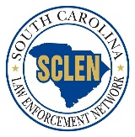
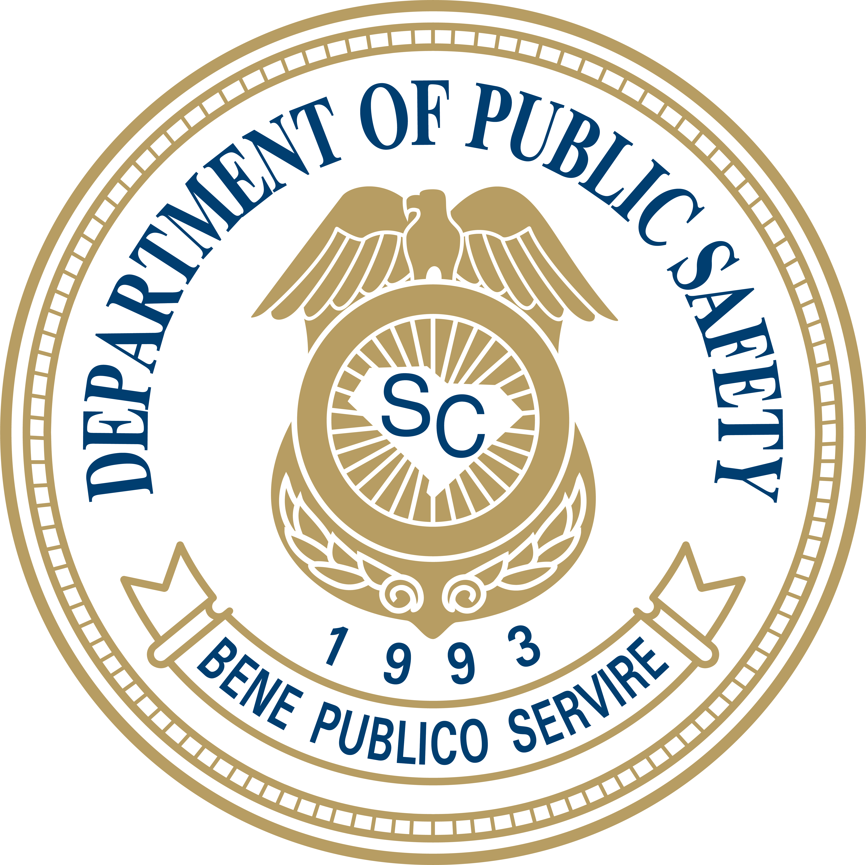

2026 Law Enforcement Challenge

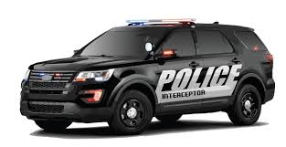

Compete for an Outfitted Patrol Vehicle
And
Hand Held Speed Measuring Devices

(Vehicle Shown only as a Representation)

Challenge Period:
December 1, 2025 – September 7, 2026

Agency Participation Requirements:

a) Have a signed Participation Statement on file with OHSJP.

b) Conduct traffic enforcement, educational initiatives, and public information as indicated below:

- Conduct monthly proactive traffic enforcement (checkpoints, saturation/directed patrols) during the challenge period (December 1, 2025 – September 7, 2026).

- Conduct stepped-up DUI enforcement during the 2025 - 2026 Christmas/New Years’ Day Sober or Slammer! Campaign, scheduled for December 12, 2025 – January 1, 2026, in addition to any monthly-impaired driving detection and enforcement efforts.

- Conduct stepped-up enforcement of the State’s safety belt and child passenger safety laws during the 2026 Memorial Day Buckle Up, South Carolina Campaign, scheduled for May 18 – May 31, 2026.

- Conduct stepped-up enforcement of the State’s speed laws during the 2026 Operation Southern Slow Down Campaign, scheduled for July 13 – July 19, 2026.

- Conduct stepped-up DUI enforcement during the 2026 Labor Day Sober or Slammer! Campaign, scheduled for August 14 – September 7, 2026, in addition to any monthly-impaired driving detection and enforcement efforts.

- Address Vulnerable Roadway User- related crashes (Motorcyclist, Pedal cyclist, Pedestrians, and Others) in your area. Use educational and enforcement efforts to reduce crashes related to those identified.

c) Submit all 13 required campaign enforcement reports: (See Attachment #1)

Note: To achieve BLUE Level status, 11 out of 13 reports must be completed and submitted within 10 days after the reporting period closes. This allows two (2) reports to be late and an agency can remain a BLUE level agency. However, those late reports must be submitted within 30 days after the close of the reporting period.

d) Attend LEN Meetings:

- Attend a minimum of 50% of the scheduled LEN meetings in your SCLEN Circuit (monthly or bi-monthly depending on the meeting schedule of your LEN) held during the challenge period (December 1, 2025–September 7, 2026). Only meetings that actually are held in person count toward the 50% threshold. The scheduled meetings for the challenge will be a minimum of four (4) and a maximum of nine (9). A sign-in sheet is maintained for each LEN meeting and will be used for verification of attendance.

Note: Agencies experiencing emergency situations, which would preclude attendance at a given meeting, must notify the LEN Circuit Coordinator or Assistant LEN Circuit Coordinator that meeting attendance is not possible, in order to be considered for meeting attendance credit. LEN Circuit Coordinators or Assistant LEN Circuit Coordinators must document on meeting rosters if such notification has been received and approved for credit.

e) Report Public Contacts (Warnings):

- Agencies must comply with the provisions of SC state statute §56-5-6560, which requires reporting of data on non-arrest and non-citation traffic stops to the SC Department of Public Safety (SCDPS). SCDPS rules and regulations require monthly reporting of this data.

- All required Public Contact reports (See attachment #1) must be submitted by October 1, 2026.

Attachment 1

2026 Law Enforcement Challenge Enforcement Reporting Schedule*

Report Period Required: | “From and To” Dates: | Due Dates
December 2025 | 12/1/2025 – 12/31/2025 | 01/10/2026
2025-26 Christmas/New Year’s SOS Campaign | 12/12/2025 – 1/1/2026 | 01/11/2026
January 2026 | 1/1/2026 – 1/31/2026 | 02/10/2026
February 2026 | 2/1/2026 – 2/28/2026 | 03/10/2026
March 2026 | 3/1/2026 – 3/31/2026 | 04/10/2026
April 2026 | 4/1/2026 – 4/30/2026 | 05/10/2026
May 2026 | 5/1/2026 – 5/31/2026 | 06/10/2026
2026 Memorial Day BUSC Campaign | 5/18/2026 – 5/31/2026 | 6/10/2026
June 2026 | 6/1/2026 – 6/30/2026 | 07/10/2026
July 2026 | 7/1/2026 – 7/31/2026 | 08/10/2026
2026 Operation Southern Slow Down Campaign | 7/13/2026 – 7/19/2026 | 07/29/2026
August 2026 | 8/1/2026 – 8/31/2026 | 09/10/2026
2026 Labor Day SOS Campaign | 8/14/2026 – 9/7/2026 | 9/17/2026

* 2025/2026 Campaign & Monthly Enforcement Report Form is online at www.scdps.gov/sclen

2026 Law Enforcement Public Contact
Reporting Schedule

Report Period Required: | “From and To” Dates:
December 2025 | 12/1/2025 – 12/31/2025
January 2026 | 1/1/2026 – 1/31/2026
February 2026 | 2/1/2026 – 2/28/2026
March 2026 | 3/1/2026 – 3/31/2026
April 2026 | 4/1/2026 – 4/30/2026
May 2026 | 5/1/2026 – 5/31/2026
June 2026 | 6/1/2026 – 6/30/2026
July 2026 | 7/1/2026– 7/31/2026
August 2026 | 8/1/2026- 8/31/2026

All reports must be submitted by October 1, 2026

AWARDS CRITERIA

BLUE LEVEL:

- At least 50% LEN meeting attendance.

- All SCLEN reports submitted as detailed in section (c) above.

- All Public Contact Reports submitted by the deadline.

- Signed Participation Form on file.

*Only BLUE level agencies with evidence of active participation through documented enforcement

activities will be eligible for any equipment and prizes.

NOTE: Completion of the Federal Surplus Property Eligibility Application is required to receive any

equipment items. (You can find the Federal Surplus Property Eligibility Application online at www.scdps.gov/sclen).

Awards and incentive items will be awarded at the 2026 Law Enforcement Challenge Ceremony

2026 Law Enforcement Challenge Participation Statement*

By signing this form, your agency is agreeing to participate in the 2026 Law Enforcement Challenge.

__________________________________________ __________________________
(Signature of Chief, Sheriff, or Designee) (Date)

Agency: ________________________________________________________________

Agency Address: _________________________________________________________

Contact Person for Law Enforcement Challenge: ________________________________

Phone #: _________________________________

E-mail Address: ____________________________

Contact Person for Public Contact Reporting: __________________________________

Phone #: _________________________________

E-mail Address: ____________________________

Signed Participation Statement Must Be Submitted to the Office of Highway Safety and Justice Programs.

* The participating agency must confirm via phone call or e-mail communication that the Participation Statement has been received at the Office of Highway Safety and Justice Programs.

E-mail or Mail a Signed Participation Statement to:

SC Dept. of Public Safety

Office of Highway Safety and Justice Programs

PO Box 1993

Blythewood, SC 29016

Gilmore S. Owens III Harold Moore

PHONE # (839) 228-5650 or PHONE # (839) 201-2020

E-mail Address: gilmoreowens@scdps.gov E-mail Address: haroldmoore@scdps.gov

